Ethan Richardson
ethanrichardsonanimate@gmail.com
www.ethanrichardson.com

Breakdown Sheet

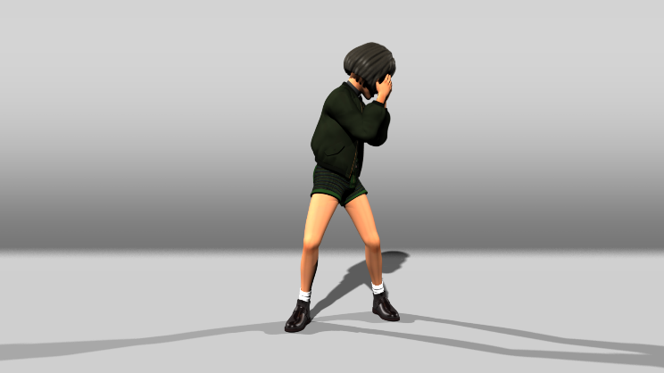 | Boxbox LipSync  Program: Maya  Responsibilities: Animation, background, lighting  Mathilda Rig is developed by Leon Li-Aun Sooi and Xiong Lin from Savannah College of Art and design.
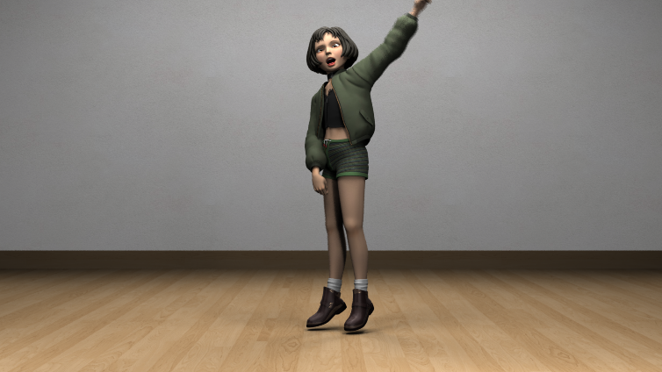 | GFriend – Me Gusta Tu Dance  Program: Maya  Responsibilities: animation, background modeling, background texturing, lighting  Mathilda Rig is developed by Leon Li-Aun Sooi and Xiong Lin from Savannah College of Art and design.
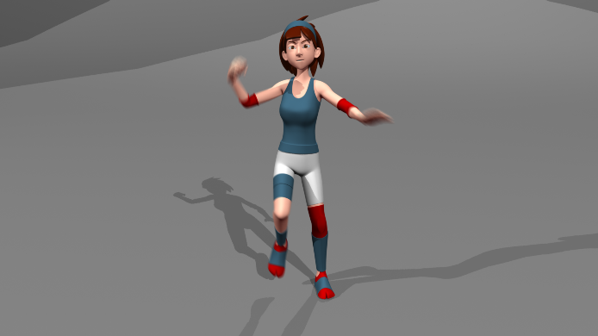 | Martial Arts Animation  Program: Maya  Responsibilities: animation  Model and Rig by On One Animation School
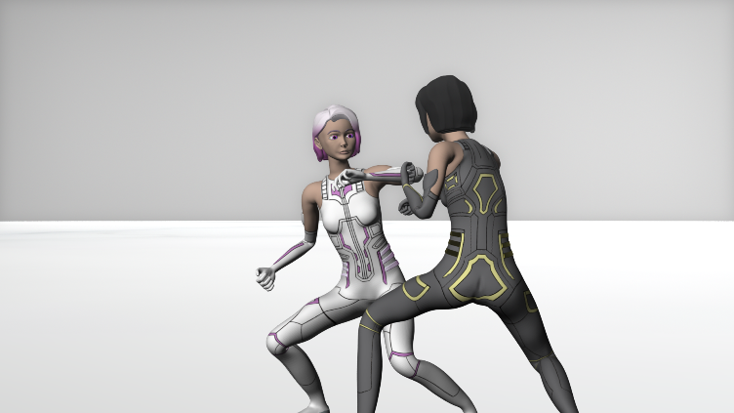 | 3N73R - Short Film  Program: Maya  Responsibilities: Everything except sound  Rigged using Advance Skeleton

